Katie Henderson
Dr. Chen
HSCI 244 W 8-11:50
05 November 2012

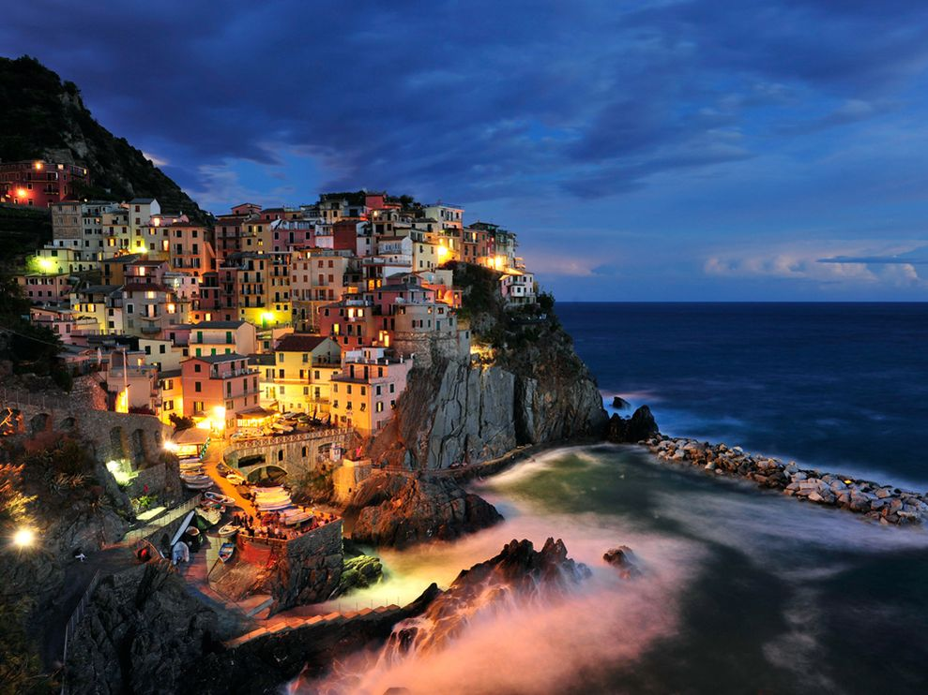

Bella Notte
Appetizer: Crostini (p. 56)
Beverage: Lemonade (p. 63)
Salad: Northern Italian White Bean Salad on bed of lettuce (p. 388)
Entrée: Homemade Pasta (p. 355) and Spaghetti and Meatballs (p. 357)
Vegetable side: Fresh Peas and Prosciutto (p. 460)
Bread/Roll: Focaccia (p. 90)
Dessert: Apple Crisp (p. 196) and Vanilla Ice cream (p. 213)

